**EXPERIMENT 12**

Write a R program to Apply Predictive analytics for Weather forecasting.

**AIM: To Apply Predictive analytics for Weather forecasting.**

**Description :** Predictive analytics uses historical data and statistical modeling to forecast future outcomes, determining the likelihood of specific events or trends

**Weather forecasting** : It involves a sequence of steps

**Step 1 :**  **Data Collection :** Data collects from Ground stations like Temperature,

humidity, wind speed, pressure, rainfall, etc.

**Step 2 : Data Preprocessing & Quality Control :** Raw data is often noisy or

incomplete, so: Missing values are estimated or removed.

Outliers are detected and handled.

**Step 3 : Feature Engineering :** To improve model performance:

Create derived variables (e.g., wind chill, heat index).

Convert date/time into cyclical features.

Convert categorical data (e.g., weather types) into numeric encodings.

**Step 4 : . Model Building :** Use Statistical or Machine Learning Models:

Use historical data to learn patterns.

Common methods: Linear regression for temperature

SVM / Decision Trees for classification (e.g., rain prediction)

Time series models like ARIMA, LSTM

**Step 5 : . Model Evaluation :**

Models are tested using Training/testing split or cross-validation

Metrics like: RMSE / MAE for temperature

Accuracy, Precision, Recall for rain or storm predictions

**Step 6 : . Forecasting :** Forecasts are generated for:

Short-term (1–3 days): Highly accurate

Medium-term (4–7 days): Good reliability

Long-term (>7 days): Increasing uncertainty

**Forecasts may include:** Temperature, Rainfall likelihood, Wind speed and

direction, Storm alerts

Program:

install.packages("lubridate")

install.packages("e1071")

library(lubridate)

library(e1071)

# Load & preprocess

weather_data <- read.csv("D:/R programming/weather_data.csv", stringsAsFactors = FALSE)

weather_data$date <- dmy(weather_data$date)

weather_data$day_of_year <- yday(weather_data$date)

weather_data$month <- month(weather_data$date)

weather_data$weekday <- wday(weather_data$date)

weather_data$rain_label <- as.factor(ifelse(weather_data$rain > 0, "Yes", "No"))

# 🔹 Initial dataset plot

dev.new()

plot(weather_data, main = "Weather Dataset", col = "green")

# Split data

set.seed(123)

idx <- sample(1:nrow(weather_data), size = 0.8 * nrow(weather_data))

train <- weather_data[idx, ]; test <- weather_data[-idx, ]

# Train models

lm_temp <- lm(temperature ~ humidity + pressure + day_of_year + month + weekday, data = train)

train$predicted_temp <- predict(lm_temp, newdata = train)

svm_rain <- svm(rain_label ~ humidity + predicted_temp + pressure + day_of_year + month + weekday,

data = train, type = "C-classification", kernel = "radial")

# Evaluate

pred_temp <- predict(lm_temp, newdata = test)

cat("RMSE:", round(sqrt(mean((test$temperature - pred_temp)^2)), 2), "\n")

summary(lm_temp)

# 🔹 Plot actual vs predicted

dev.new()

plot(test$temperature, pred_temp, col = "blue", pch = 16,

main = "Actual vs Predicted Temperature",

xlab = "Actual", ylab = "Predicted")

abline(0, 1, col = "red", lwd = 2)

# Forecast next 7 days

future_dates <- seq(max(weather_data$date) + 1, by = "day", length.out = 7)

future <- data.frame(

date = future_dates,

day_of_year = yday(future_dates),

month = month(future_dates),

weekday = wday(future_dates),

humidity = mean(train$humidity),

pressure = mean(train$pressure)

)

future$predicted_temp <- predict(lm_temp, newdata = future)

future$predicted_temperature <- round(future$predicted_temp, 2)

future$rain_prediction <- ifelse(as.character(predict(svm_rain, newdata = future)) == "Yes", "RAIN=YES", "RAIN=NO")

# 🔹 Show forecast

cat("\nNext 7 Days Forecast:\n")

print(future[, c("date", "predicted_temperature", "rain_prediction")])

# 🔹 Forecast plot

dev.new()

plot(future$date, future$predicted_temperature, type = "o", col = "red", lwd = 4, pch = 5,

main = "7-Day Forecast: Temperature & Rain",

xlab = "Date", ylab = "Temperature (°C)")

text(future$date, future$predicted_temperature + 0.4, labels = future$predicted_temperature, col = "red")

rain_colors <- ifelse(future$rain_prediction == "RAIN=YES", "blue", "magenta")

text(future$date, future$predicted_temperature + 1, labels = future$rain_prediction, col = rain_colors, font = 2)

legend("topright", legend = c("Temperature", "RAIN=YES", "RAIN=NO"),

col = c("red", "blue", "magenta"), pch = 16, bty = "n")

# 🔹 Raw temperature with rain points

dev.new()

plot(weather_data$date, weather_data$temperature, type = "o", col = "magenta", lwd = 2, pch = 16,

main = "Temperature Over Time", xlab = "Date", ylab = "Temperature (°C)")

points(weather_data$date[weather_data$rain > 0],

weather_data$temperature[weather_data$rain > 0],

col = "blue", pch = 17, cex = 1.2)

legend("topright", legend = c("Temperature", "Rainy Days"),

col = c("magenta", "blue"), pch = c(16, 17), bty = "n")

**OUTPUT:**

> head(weather_data )

date temperature humidity pressure rain

1 2024-01-01 32.01821 73.83717 1022.128 0

2 2024-01-02 32.79764 45.20104 1012.928 1

3 2024-01-03 10.01488 45.15971 1021.298 1

4 2024-01-04 29.06567 57.22615 1011.070 1

5 2024-01-05 22.46109 95.97190 1003.947 0

6 2024-01-06 18.16836 97.38256 1011.058 0

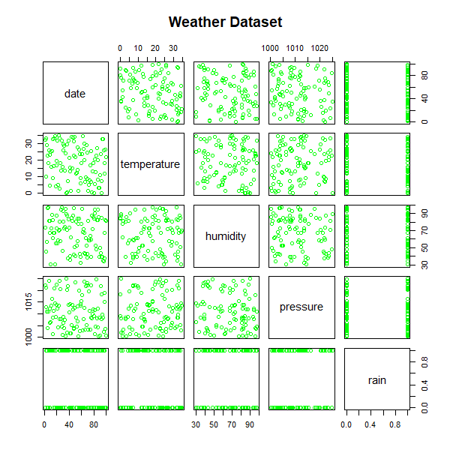

Root Mean Squared Error (RMSE): 10.86

> #Summary of Models

> summary(model_temp)

Call:

lm(formula = temperature ~ humidity + pressure + day_of_year +

month + weekday, data = train_data)

Residuals:

Min 1Q Median 3Q Max

-16.4739 -9.5256 0.7116 8.9975 16.6716

Coefficients:

Estimate Std. Error t value Pr(>|t|)

(Intercept) -35.73927 174.87503 -0.204 0.839

humidity -0.02731 0.06225 -0.439 0.662

pressure 0.05533 0.17191 0.322 0.748

day_of_year -0.17027 0.13703 -1.243 0.218

month 3.19049 3.97729 0.802 0.425

weekday 0.36879 0.58653 0.629 0.531

Residual standard error: 10.41 on 74 degrees of freedom

Multiple R-squared: 0.05175, Adjusted R-squared: -0.01232

F-statistic: 0.8077 on 5 and 74 DF, p-value: 0.5479

> summary(model_rain_svm)

Call:

svm(formula = rain_label ~ humidity + predicted_temp +

pressure + day_of_year + month + weekday,

data = train_data, type = "C-classification",

kernel = "radial")

Parameters:

SVM-Type: C-classification

SVM-Kernel: radial

cost: 1

Number of Support Vectors: 72

( 38 34 )

Number of Classes: 2

Levels:

No Yes

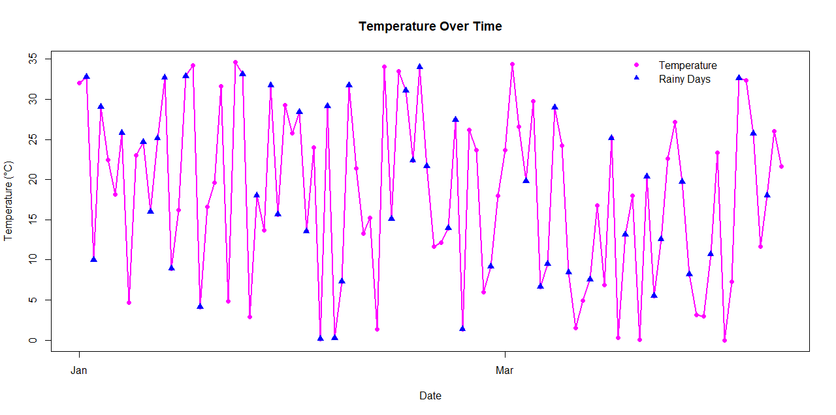

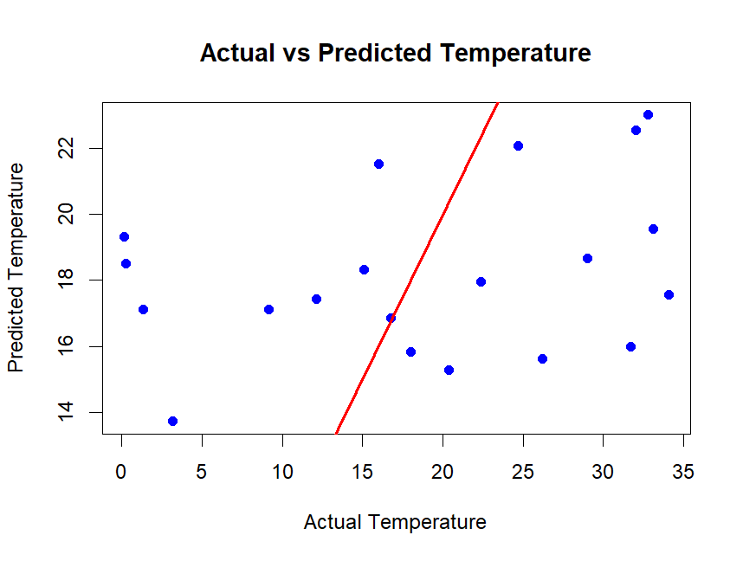

Next 7 Days Forecast:

date predicted_temperature rain_prediction

1 2024-04-10 15.47 RAIN=NO

2 2024-04-11 15.67 RAIN=NO

3 2024-04-12 15.87 RAIN=NO

4 2024-04-13 16.07 RAIN=NO

5 2024-04-14 13.68 RAIN=NO

6 2024-04-15 13.88 RAIN=NO

7 2024-04-16 14.08 RAIN=NO

**Experiment 7 Date :**

**-------------------------------------------------------------------------------------------------------------------------------**

**Experiment 1 : Write a R program to Implement**  **ARIMA on Time Series data**

**Aim:** Write a R program program to Implement ARIMA on Time Series data

**Description :**

**ARIMA** (Autoregressive Integrated Moving Average) is a statistical model used for time series analysis and forecasting, predicting future values by combining past observations (AR), differencing to achieve stationarity (I), and past errors to refine predictions (MA).

ARIMA models explain a given time series based on its own past values (lags) and lagged forecast errors.

Components:

**Autoregressive (AR):** This part of the model uses past values of the time series to predict future values.

**Integrated (I):** This component addresses non-stationarity by differencing the time series data, making it stationary (i.e., having a constant mean and variance over time).

**Moving Average (MA):** This part incorporates past forecast errors to improve the accuracy of future predictions.

**Notation:**

A non-seasonal ARIMA model is often represented as ARIMA(p, d, q), where:

**p** is the order of the autoregressive (AR) part.

**d** is the order of integration (the number of times the data needs to be differenced).

**q** is the order of the moving average (MA) part.

**To** **build an ARIMA model:**

**Data Preparation:** Collect and prepare the time series data.

**Stationarity** **Check:** Ensure the data is stationary or make it stationary through differencing.

**Model Identification**: Determine the appropriate values for p, d, and q using techniques like autocorrelation function (ACF) and partial autocorrelation function (PACF) plots.

**Parameter Estimation:** Estimate the model parameters using techniques like maximum likelihood estimation.

**Model Evaluation:** Evaluate the model's performance using metrics like root mean squared error (RMSE) or mean absolute error (MAE).

**Steps involved in ARIMA Model :**

**1. Load and Prepare the Time Series Data**

For demonstration, we use the built-in AirPassengers dataset.

**2. Check for Stationarity**

ARIMA requires a stationary series, meaning that statistical properties like mean and variance should be constant over time.

If p-value > 0.05, the data is non-stationary, and we apply differencing.

If p-value ≤ 0.05, the data is stationary.

**3. Apply Differencing (If Necessary)**

If the time series is non-stationary, differencing is required.

**4. Identify ARIMA Parameters (p, d, q)**

Determine ARIMA parameters manually using ACF (AutoCorrelation Function) and PACF (Partial AutoCorrelation Function) plots.

**Applications:**

ARIMA models are widely used for various time series forecasting tasks, including:

Predicting stock prices.

Forecasting sales and demand.

Analyzing financial data.

Understanding and predicting trends in various datasets

**Program:**

# Install and load required packages

if (!require(forecast)) install.packages("forecast", dependencies = TRUE)

if (!require(tseries)) install.packages("tseries", dependencies = TRUE)

library(forecast)

library(tseries)

# Load time series data

ts_data <- AirPassengers

# 📌 Plot original time series

dev.new()

plot(ts_data, main = "AirPassengers Time Series", ylab = "Passengers", col = "blue")

# 📌 ADF test for stationarity

adf_result <- adf.test(ts_data)

print(adf_result)

# 📌 ACF & PACF plots

dev.new(); acf(ts_data, main = "ACF Plot")

dev.new(); pacf(ts_data, main = "PACF Plot")

# 📌 Apply differencing if needed

ts_diff <- if (adf_result$p.value > 0.05) {

  print("Differencing applied.")

  diff(ts_data)

} else ts_data

# 📌 Re-check ADF test

print(adf.test(ts_diff, na.action = na.omit))

# 📌 Fit best ARIMA model

best_arima <- auto.arima(ts_data)

summary(best_arima)

# 📌 Forecast next 12 months

fc <- forecast(best_arima, h = 12)

# 📌 Plot forecast

dev.new(); plot(fc, main = "ARIMA Forecast", col = "blue")

# 📌 Forecast values

print(fc)

# 📌 Residual diagnostics

checkresiduals(best_arima)

**Output :**

Augmented Dickey-Fuller Test

data: ts_data

Dickey-Fuller = -7.3186, Lag order = 5, p-value =

0.01

alternative hypothesis: stationary

